EXERCISE 11 - JEAN RAVEN MAGALING

- Count the number of employees who have been with Bignet for four or more years.
SELECT COUNT(*) AS employees_with_4plus_years
FROM employee_data
WHERE yos >= 4;
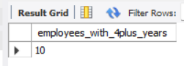
- Count employees based on their ages.
SELECT age, COUNT(*) AS number_of_employees
FROM employee_data
GROUP BY age;
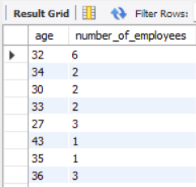
- Modify the above so that the ages are listed in a descending order.
SELECT age, COUNT(*) AS number_of_employees
FROM employee_data
GROUP BY age
ORDER BY age DESC;
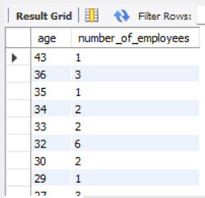

- Find the average age of employees in different departments (titles).
SELECT title, AVG(age) AS average_age
FROM employee_data
GROUP BY title;
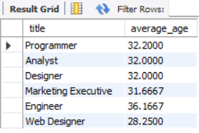
- Change the above statement so that the data is displayed in descending order of average ages.
SELECT title, AVG(age) AS average_age
FROM employee_data
GROUP BY title
ORDER BY average_age DESC;
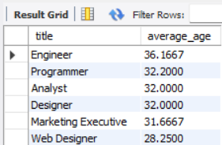
- Find and list the percentage perk for each employee
SELECT
f_name,
l_name,
perks,
salary,
(perks / salary * 100) AS perk_percentage
FROM employee_data
ORDER BY perk_percentage DESC;
